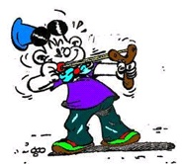
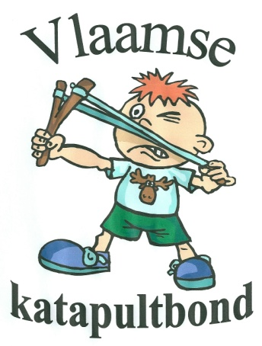
European Championship
Slingshot
Eernegem, Belgium
July, 24, 25, 26 of 2020.

Slingshotclub Bekegem
in coörporation with
Flemish Slingshot Federation

Rules and regulations

Friday July 24 Opening shooting

START 18.00 Hour.

Registration is always possible during the evening
Distance 10 meters

Competition : 4 different targets

- GOLF BALLS
5 balls – 5 shots – 5 points for each fallen ball.
Maximum 25 points.
- PAPER PURPOSES
Paper with 3 targets - 9 shots – 3 in each target.
When a 4th hit is fired within the same target, the altitude score is dropped.
Maximum 90 points.
- MOVING TARGET
10 shots – 5 points for each fallen target
Maximum 50 points.
- CZECH TARGET
1 target plate that is straightened each time
10 shots – 3 points for each fallen target
Maximum 30 points.

All points are added together/
In ex aequo camps on paper with 1 large target - 3 shots.

A trophy for the first 3 men
A trophy for the first 3 women
A trophy for the first 3 youthshooters

A meal with bread will be offered during the match. This will not be interrupted!

Saturday, July 25 EUROPEAN CHAMPIONSHIP 2020.
INDIVIDUAL

- Reception at 11 o'clock
- Presentation countries landen at 12 o'clock
- first shots by local dignitaries from 12.45 hour.

START EUROPEAN CHAMPIONSHIP INDIVIDUAL AT 13.OO HOUR.

- Inscription till 11.00 hour. Afterwards NO longer possible.
- 7 shots per turn. A match consists of 3 times 2 turns.
The game will be shut down to allow the officials to have a meal.

The game :
- be shot on Belgian stands
- Each shooter will shoot at the targets assigned to him, no shooter will shoot twice at the same targets
- In the very first turn one gets 10 shots. The first 3 shots are exercise. Then the targets are straightened out. Then the points are counted.
- The target plates must be hit directly. If a plate falls when it has been hit through the support beam, the referee will report it. The goal plates shall be straightened again. Those plates that have already been fired over shall continue to count. When a goal plate is hit in the another stand, the goal plates must also be straightened in that position. The goal plates that have already been fired continue to count.
- At ex aequo abbreviation to Belgian custom, only for places 1, 2 and 3!
- The target to be hit is determined by cards and is called. Only the called and shot targets count. When another plate is hit, they will be straightened again, the plates already shot will continue to count.
- Targets already shot continue to count.
- THE DECISION OF THE REFEREES IS BINDING AND IRREVOCABLE

There is a trophy for ;
Places 1, 2 and 3 by the men
Places 1, 2 and 3 by the woman
Places 1, 2 and 3 bij the youth shooters

Sunday, July 26 EUROPEAN CHAMPIONSHIP FOR
NATIONAL TEAMS

START OF THE COMPETITION 11.00 HOUR

- 1 team of 4 shooters per country will be called up.
- There is shooting on Belgian targets.
- 1 team shooting together on 4 stands.
- Every team member shoots 2 turns.
- After this 2 turns changing country.
- When each country has completed the first 2 turns, each country will be called back for the 2nd round.
- The same rules as in the individual championship.
- All points counting together.
- If necessary ex aequo at the first 3 places, camp on paper target with 1 disc. 4 shooters, 1 shot each.

- A trophy is provided for the places 1, 2 and 3.
The team members from this 3 teams get a medal.

- The awarding of the trophies of all matches shot, after this match.

Sunday, July 26 Couple game.

START 14.00 HOUR

- The teams will be composed based on the results of the game on Saturday. The winner shoots his race with the last one in that ranking, the 2nd shoots his race with the penultimate one in that ranking, etc, etc, etc.
- Shots will be fired on the Belgian stands.
- Each shooter gets 7 marbles.
- Each team shoots on 1 position.
- It's your turn to shoot, first one shooter, then the other shooter.
- After the first turn, the second turn is immediately finished on another stand but in the same cage.
- Each team shoots only 2 turns.
- The points are added together.

- In case of equality of points to camp (only for places 1, 2 and 3!) is done on paper targets with 3 discs. Each shooter of the duo shoots 1 shot in each disc.

GENERAL POINTS.

- YOUTH SHOOTERS
The youth shooters are these persons up to and including year of birth in 2020.
- AMMUNITION
Only round ammunition, such as steel or lead balls, glass or plastic marbles. Glass marbles of 16 mm are offered by the organization.
- SLINGSHOTS
All catapults are allowed, but arm and/or wrist supports are forbidden!
- TARGETS
The targets should be hit RIGHT. The points only count when the target is down!
- REFEREES
Behind each shooter there will be an referee who will write down each shot.
The referee's decision shall be final and binding.
- TRAINING
There's no way to train on the spot, SURGE NO OUTSIDE!!!!!!!!!!
under penalty of DISQUALIFICATION!!!!!

PARTICIPATION PRICE
- The price of participation is €20 and is indivisible.
For this price; you can participate in all competitions, you have a bread meal on Friday and you are insured during the competitions.

(We converted this text with a translator (DeepL).
Nevertheless, some mistakes may have been made. Sorry about that).

